We are geographers: St Georges Curriculum Overview
We are historians: St Georges Curriculum Overview

Year 1
Term 1-2 | Term 3-4 | Term 5-6
History: Childhood  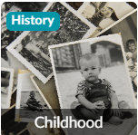 | Geography: Our Wonderful World  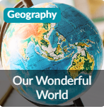 | Geography: Bright Lights, Big City  
This project teaches children about everyday life and families today, including comparisons with childhood in the 1950s, using artefacts and a range of different sources | This essential skills and knowledge project teaches children about physical and human features, maps, cardinal compass points, and positional and directional language. They learn about the equator, hemispheres and continents and are introduced to the countries, capital cities and settlements of the United Kingdom. The children carry out simple fieldwork to find out about local physical and human features. | This project teaches children about the physical and human characteristics of the United Kingdom, including a detailed exploration of the characteristics and features of the capital city, London.

Year 2
Term 1-2 | Term 3-4 | Term 5-6
History: Movers and Shakers   | Geography: Let’s Explore the World  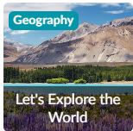 | Geography: Coastline  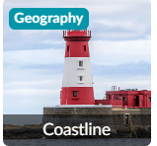
This project teaches children about historically significant people who have had a major impact on the world. They will learn to use timelines, stories and historical sources to find out about the people featured and use historical models to explore their significance. | This essential skills and knowledge project teaches children about atlases, maps and cardinal compass points. They learn about the characteristics of the four countries of the United Kingdom and find out why there are hot, temperate and cold places around the world. They also compare England to Somalia. Children carry out fieldwork, collecting primary data in their locality to answer geographical questions. | This project teaches children about the physical and human features of coastal regions across the United Kingdom, including a detailed exploration of the coastal town of Whitby, in Yorkshire.

Year 3
Term 1-2 | Term 3-4 | Term 5-6
History: Through the Ages  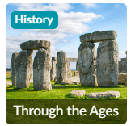 | Geography: One Planet, Our World  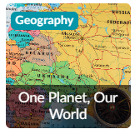 | Geography: Rocks, Relics and Rumbles  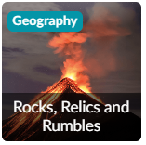
This project teaches children about British prehistory from the Stone Age to the Iron Age, including changes to people and lifestyle caused by ingenuity, invention and technological advancement. | This essential skills and knowledge project teaches children to locate countries and cities, and use grid references, compass points and latitude and longitude. They learn about the layers of the Earth and plate tectonics and discover the five major climate zones. They learn about significant places in the United Kingdom and carry out fieldwork to discover how land is used in the locality. | This project teaches children about the features and characteristics of Earth's layers, including a detailed exploration of volcanic, tectonic and seismic activity.

Year 4
Term 1-2 | Term 3-4 | Term 5-6
History: Invasion  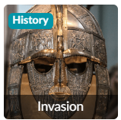 | Geography: Misty Mountain, Winding River  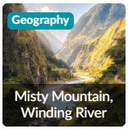 | History: Ancient Civilisations  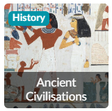
This project teaches children about life in Britain after the Roman withdrawal. Children will learn about Anglo-Saxon and Viking invasions up to the Norman conquest. | This project teaches children about the characteristics and features of rivers and mountain ranges around the world, including a detailed exploration of the ecosystems and processes that shape them and the land around them. | This project teaches children about the history of three of the world’s first ancient civilisations: ancient Sumer, ancient Egypt and the Indus Valley civilisation. Children will learn about the rise, life, achievements and eventual end of each civilisation.
Geography: Interconnected World
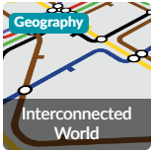
This essential skills and knowledge project teaches children about compass points and four and six-figure grid references. They learn about the tropics and the countries, climates and culture of North and South America. Children identify physical features in the United Kingdom and learn about the National Rail and canal networks. They conduct an enquiry to prove a hypothesis, gathering data from maps and surveys before drawing conclusions

Year 5
Term 1-2 | Term 3-4 | Term 5-6
History: Dynamic Dynasties  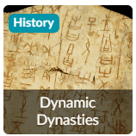 | Geography: Sow, Grow and Farm  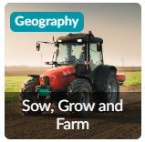 | History: Groundbreaking Greeks  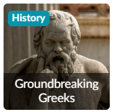
This project teaches children about the history of ancient China, focusing primarily on the Shang Dynasty, and explores the lasting legacy of the first five Chinese dynasties, some of which can still be seen in the world today. | This project teaches children about the features and characteristics of land use in agricultural regions across the world, including a detailed exploration of significant environmental areas. | This project teaches children about developments and changes over six periods of ancient Greek history, focusing on the city state of Athens in the Classical age, and exploring the lasting legacy of ancient Greece.
Geography: Investigating Our World
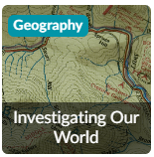
This essential skills and knowledge project teaches children about locating map features using a range of methods. They learn about the Prime Meridian, Greenwich Mean Time (GMT), and worldwide time zones and study interconnected climate zones, vegetation belts and biomes. Children learn about human geography and capital cities worldwide before looking at the UK motorway network and settlements. They carry out an enquiry to identify local settlement types

Year 6
Term 1-2 | Term 3-4 | Term 5-6
History: Maafa  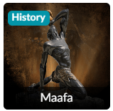 | History: Britain at War  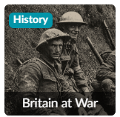 | Geography: Frozen Kingdoms  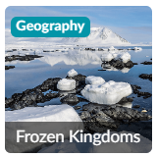
This project teaches children about Africa past and present, with a particular focus on Benin. It traces the development of the slave trade and explores Britain’s role in the transatlantic slave trade, the causes and consequences of the European colonisation of Africa and the worldwide communities that make up the African diaspora | This project teaches children about the causes, events and consequences of the First and Second World Wars, the influence of new inventions on warfare, how life in Great Britain was affected and the legacy of the wars in the post-war period. | This project teaches children about the characteristics and features of polar regions, including the North and South Poles, and includes a detailed exploration of the environmental factors that shape and influence them.
Geography: Our Changing World
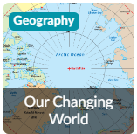
This essential skills and knowledge project revises the features of Earth, time zones and lines of latitude and longitude to pinpoint places on a map. Children find out more about map scales, grid references, contour lines and map symbols. They learn about climate change and the importance of global trade. Children analyse data and carry out fieldwork to find out about local road safety. They study patterns of human settlements and carry out an enquiry to describe local settlement patterns.

