We are mathematicians: St Georges Curriculum Overview: Year 1
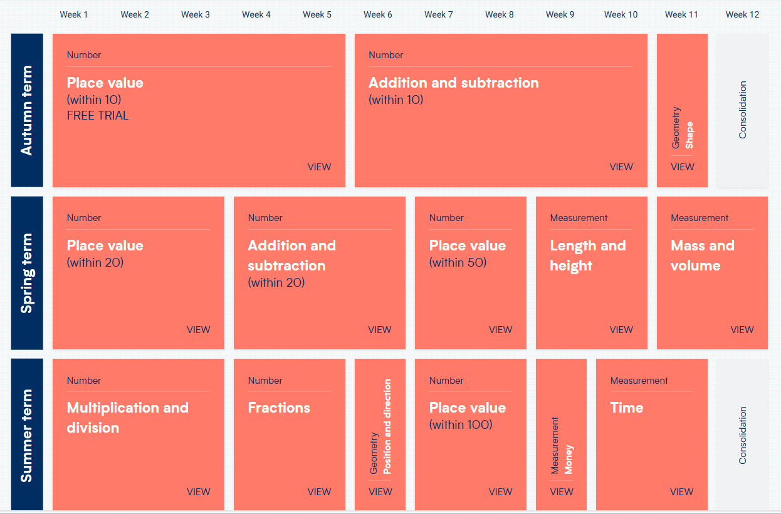
We are mathematicians: St Georges Curriculum Overview: Year 2
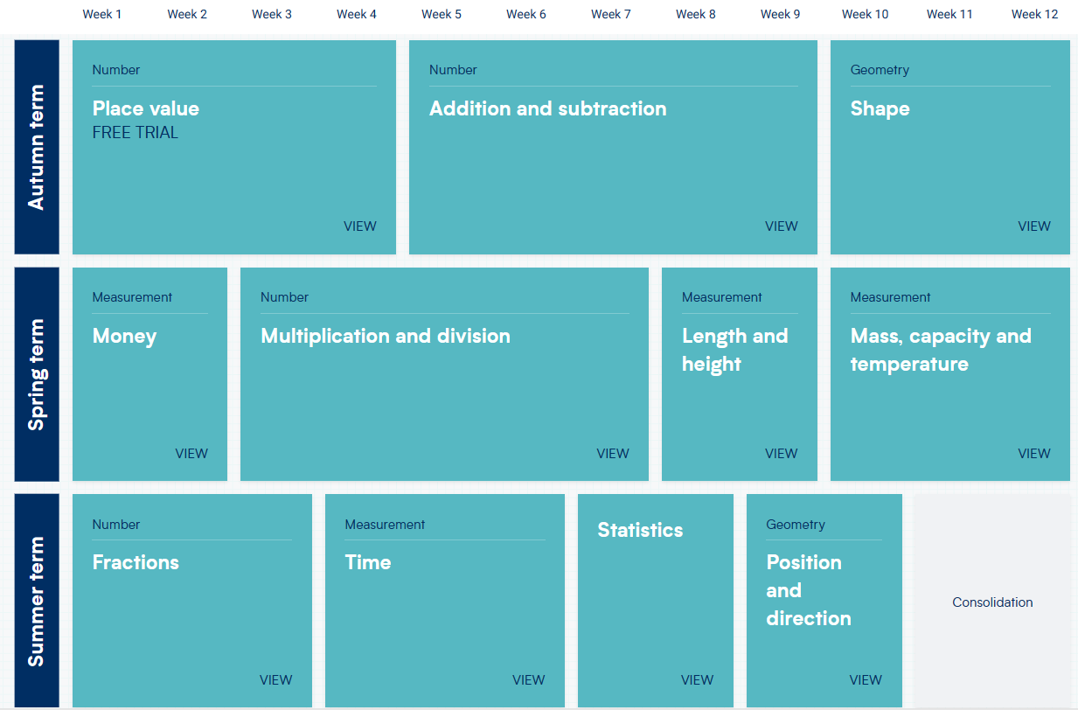
We are mathematicians: St Georges Curriculum Overview: Year 3
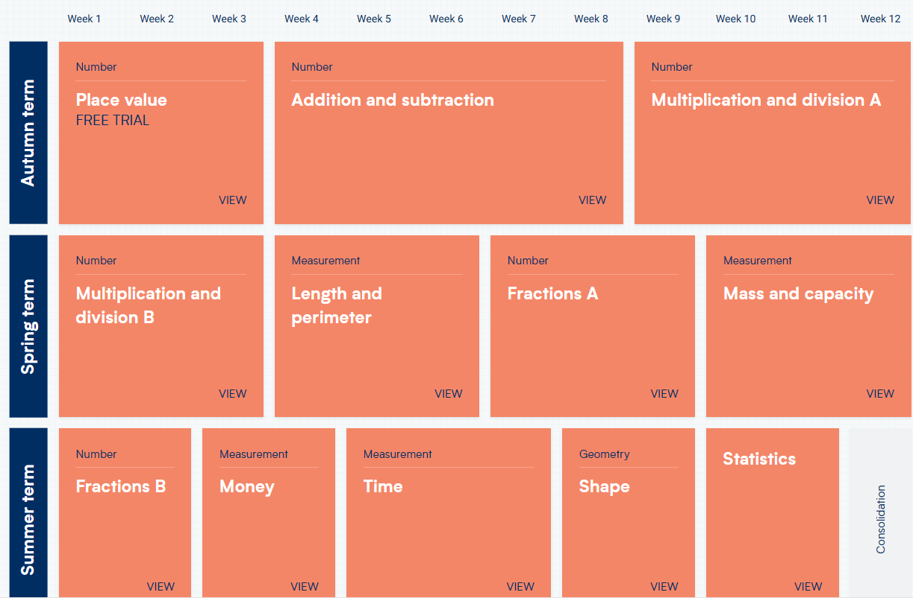
We are mathematicians: St Georges Curriculum Overview: Year 4
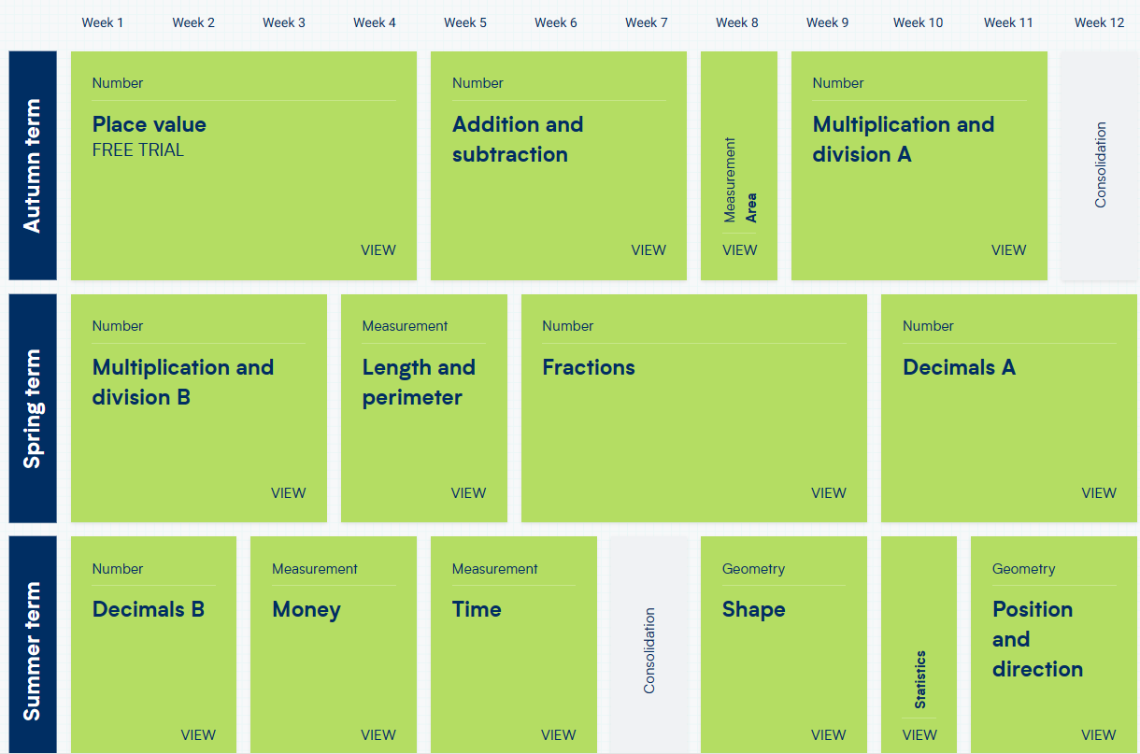
We are mathematicians: St Georges Curriculum Overview: Year 5
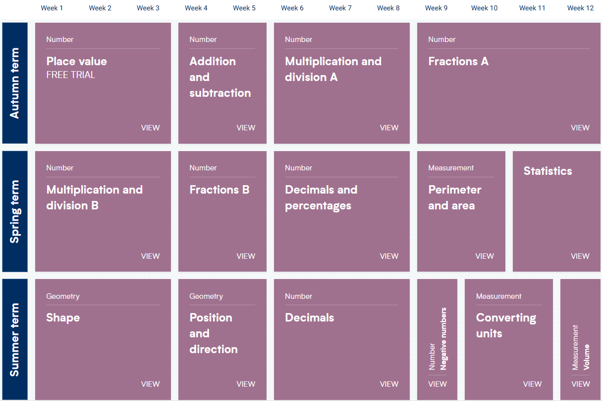
We are mathematicians: St Georges Curriculum Overview: Year 6


