DT | Term 1 and 2 | Term 3 and 4 | Term 5 and 6
Nursery | In the moment planning | In the moment planning | In the moment planning
Year R | See EYFS long term plan | See EYFS long term plan | See EYFS long term plan
Year 1 | Shades and shelters  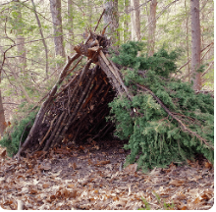  This project teaches children about the purpose of shelters and their materials. They name and describe shelters and design and make shelter prototypes. Children then design and build a play den as a group and evaluate their completed product | taxi    This project teaches children about wheels, axles and chassis and how they work together to make a vehicle move. | Chop, slice, mash  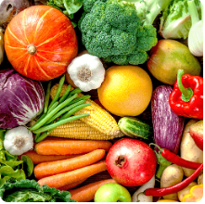  This project teaches children about sources of food and the preparatory skills of peeling, tearing, slicing, chopping, mashing and grating. They use this knowledge and techniques to design and make a supermarket sandwich according to specific design criteria.
Year 2 | Remarkable recipes  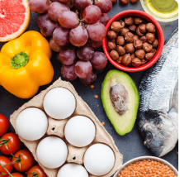  This project teaches children about sources of food and tools used for food preparation. They also discover why some foods are cooked and learn to read a simple recipe. The children choose and make a new school meal that fulfils specific design criteria. | Beach hut  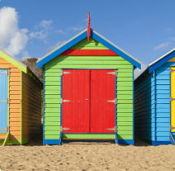  This project teaches children about making and strengthening structures, including different ways of joining materials. | Push and pull  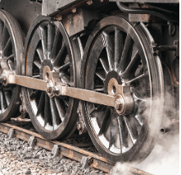  This project teaches children about three types of mechanism: sliders, levers and linkages. They make models of each mechanism before designing and making a greetings card with a moving part.  Cut, stitch and join  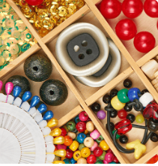  This project teaches children about fabric home products and the significant British brand Cath Kidston. They learn about sewing patterns and using a running stitch and embellishments before making a sewn bag tag.
Year 3 | Cook well, eat well  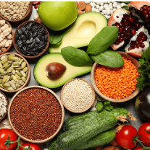  This project teaches children about food groups and the Eatwell guide. They learn about methods of cooking and explore these by cooking potatoes and ratatouille. The children choose and make a taco filling according to specific design criteria. | Making it move  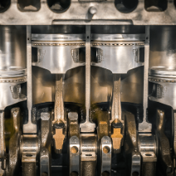  This project teaches children about cam mechanisms. They experiment with different shaped cams before designing, making and evaluating a child's automaton toy. | Greenhouse  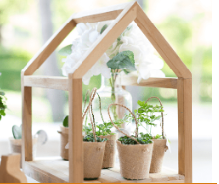  This project teaches children about the purpose, structure and design features of greenhouses, and compares the work of two significant greenhouse designers. They learn techniques to strengthen structures and use tools safely. They use their learning to design and construct a mini greenhouse.
Year 4 | Fresh food, good food  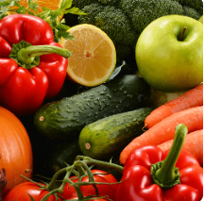  This project teaches children about food decay and preservation. They discover key inventions in food preservation and packaging, then make examples. The children prepare, package and evaluate a healthy snack. | Functional and fancy 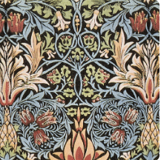  This project teaches children about home furnishings and the significant designer William Morris. They learn techniques for decorating fabric, including block printing, hemming and embroidery and use them to design and make a fabric sample. | Tomb builders  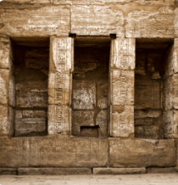  This project teaches children about simple machines, including wheels, axles, inclined planes, pulleys and levers, exploring how they helped ancient builders to lift and move heavy loads.
Year 5 | Moving mechanisms  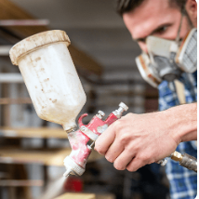  This project teaches children about pneumatic systems. They experiment with pneumatics before designing, making and evaluating a pneumatic machine that performs a useful function. | Eat The seasons!  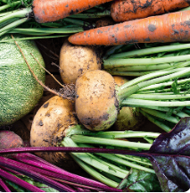  This project teaches children about the meaning and benefits of seasonal eating, including food preparation and cooking techniques. | Architecture  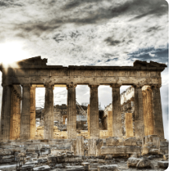  This project teaches children about how architectural style and technology has developed over time and then use this knowledge to design a building with specific features.
Year 6 | Food for life  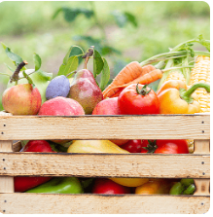  This project teaches children about processed food and healthy food choices. They make bread and pasta sauces and learn about the benefits of whole foods. They plan and make meals as part of a healthy daily menu and evaluate their completed products. | Engineer  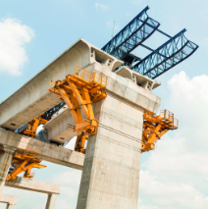  This project teaches children about remarkable engineers and significant bridges, learning to identify features, such as beams, arches and trusses. They complete a bridge-building engineering challenge to create a bridge prototype. | Make do and Mend  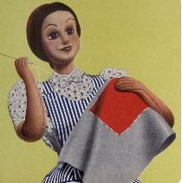  This project teaches children a range of simple sewing stitches, including ways of recycling and repurposing old clothes and materials.

