Bath and Wells Diocesan Academies Trust

PSHE School Procedures

School procedures
Saint Georges Church School PSHE and RSHE Policy
Policy Date: March 2026
Review Date: March 2028
Member of staff responsible: Sarah Starr
Our School Vision for PSHE
At St Georges Church School. we teach Personal, Social, Health and Economic Education as a whole-school approach to underpin children's development as people and because we believe that this also supports their learning capacity.
PSEH and RSE are taught through 1Decision which offers us a comprehensive, carefully thought-through scheme of work which brings consistency and progression to our children's learning in this vital curriculum area. The overview of the programme can be seen on the school website.
This also supports the "Personal Development" and "Behaviour and Attitude" aspects required under the Ofsted Inspection Framework, as well as significantly contributing to the school's Safeguarding and Equality Duties, the Government's British Values agenda and the SMSC (Spiritual, Moral, Social, Cultural) development opportunities provided for our children.
Statutory Relationships and Health Education
"The Relationships Education, Relationships and Sex Education and Health Education (England) Regulations 2019, made under sections 34 and 35 of the Children and Social Work Act 2017, make Relationships Education compulsory for all pupils receiving primary education. They also make Health Education compulsory in all schools except independent schools." DfE Guidance p.8
Here at St Georges Church School, we value PSHE as one way to support children's development as human beings, to enable them to understand and respect who they are, to empower them with a voice and to equip them for life and learning.
We include the statutory Relationships and Health Education within our whole-school PSHE Programme, in line with the overarching approach and beliefs of the Bath and Wells Multi Academy Trust.
To ensure progression and a spiral curriculum, we 1Decision as our chosen teaching and learning programme and tailor it to our children's needs.
PSHE Content and Delivery- A Whole-school approach
1Decision covers all areas of PSHE for the primary phase including statutory Relationships and Health Education. The table below contains the modules and topics taught across the school.
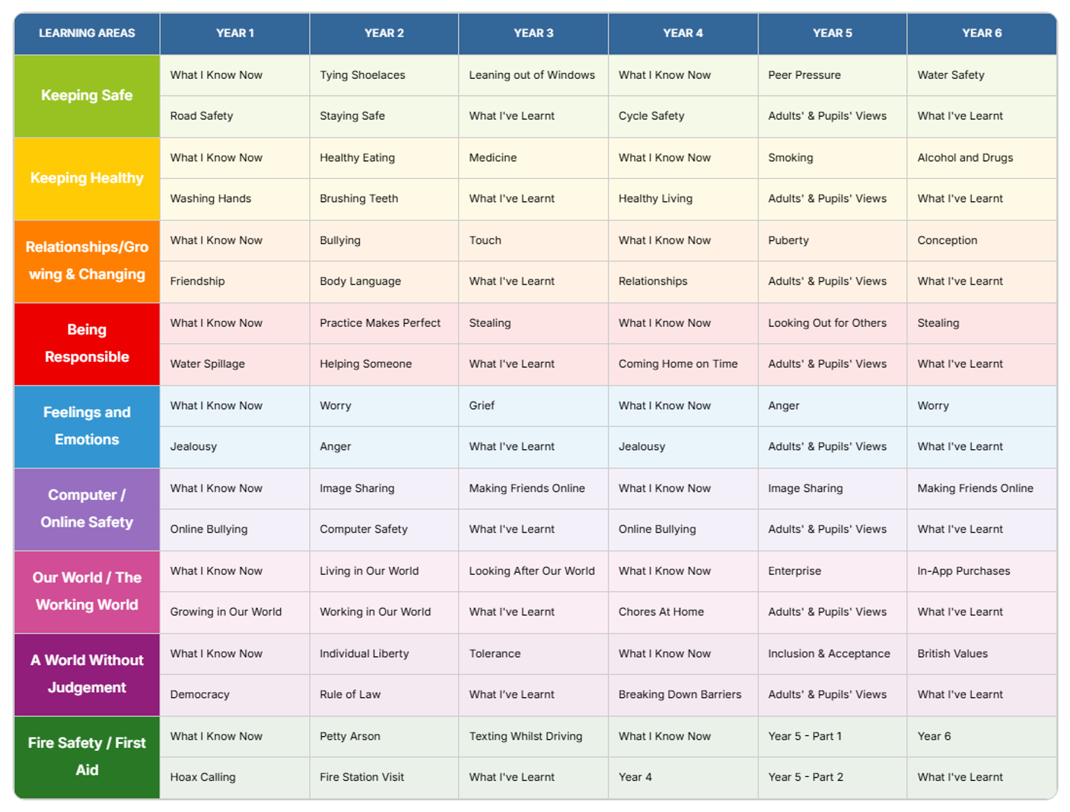

At St Georges, we allocate dedicated sessions to PSHE each week in order to teach the knowledge and skills required in a developmental and age-appropriate way.
These explicit lessons are reinforced and enhanced in many ways:
- Collective worship
- Praise and reward system
- CREW
- Through relationships child to child, adult to child and adult to adult across the school
Relationships Education
Relationships Education in primary schools covers 'Families and people who care for me', 'Caring friendships', 'Respectful relationships', 'Online relationships', and 'Being safe'.
Although the ‘relationships’ theme covers most of the statutory Relationships Education, some of the outcomes are also taught elsewhere within our curriculum.

Health Education
Health Education in primary schools covers 'Mental wellbeing', 'Internet safety and harms', 'Physical health and fitness', 'Healthy eating', 'Drugs, alcohol and tobacco', 'Health and prevention', 'Basic First Aid', and 'Changing adolescent body'.
Many of the statutory Health Education outcomes are taught through the themes ‘keeping and staying safe’ ‘keeping and staying healthy’ ‘computer safety’ and ‘growing and changing.’

Sex Education
At St Georges Church School. we believe children should understand the facts about human reproduction before they leave primary school, in line with recommendations from the DfE.
We define Sex Education as the teaching of content related to conception and reproduction, as well as the function of the male and female reproductive systems. This also includes the legal age of consent.
We teach this through our PSHE lessons during a topic on ‘conception’ in Year 6. This builds on previous knowledge around puberty, taught in Years 4 and 5.
Working with Parents and Carers
At St Georges Church School, we recognise that parents and carers are the primary educators of their children, especially in matters of relationships and values. Their role is vital in helping children to grow, mature and form healthy relationships.
We are committed to building positive and supportive relationships with our parents and carers through mutual understanding, trust, and cooperation. To achieve this, we:
- Share information about our RSHE policy and curriculum through letters, the school website, and parent meetings
- Welcome questions from parents/carers about our RSHE programme and their child's involvement
- Listen carefully to any concerns raised by parents/carers about the policy or curriculum content
- Consider parental feedback when reviewing our RSHE policy and resources
- Provide guidance on how parents/carers can support RSHE learning at home
We believe that children benefit most when they receive consistent messages at home and school. We therefore share information with parents regarding the curriculum content and offer for them to view resources before more sensitive topics are taught. A meeting is available on request.
Right to Withdraw from Sex Education
Parents cannot withdraw their child from Relationships Education, Health Education, or the Science Curriculum, as these are statutory requirements.
However, parents do have the right to request that their child be withdrawn from some or all of the Sex Education delivered as part of our RSHE curriculum (specifically lessons covering human reproduction beyond the Science Curriculum).In 1Decision, we feel these lessons are taught within the Year 6 topic of conception.
If a parent wishes to withdraw their child, they should:
- Contact the Headteacher in writing
- Meet with the Headteacher to discuss their concerns
- Understand which specific lessons their child would be withdrawn from
During this discussion, the Headteacher will:
- Explain the content and purpose of the Sex Education curriculum
- Discuss the benefits of receiving this education in school
- Consider any potential social or emotional impacts of being withdrawn
If a child is excused from Sex Education, they will be provided with purposeful, supervised education during this time.
Addressing Sensitive Questions and Topics
Our staff approach all RSHE topics with professionalism and objectivity. While we respect that people hold different personal views, all topics are presented factually and without bias, allowing pupils to form their own informed opinions while respecting diverse viewpoints.
When pupils ask questions, teachers will:
- Respond in an age-appropriate way
- Consider whether to answer immediately, later in a small group, or individually
- Use age-appropriate, factual language
- Redirect questions to parents/carers when they go beyond the planned curriculum, if appropriate
We have established clear protocols for handling questions, including:
- Anonymous question boxes where pupils can submit queries
- Guidelines for teachers on addressing different types of questions
- Procedures for consulting with senior staff or our Designated Safeguarding Lead when needed
All pupils will be treated with equal respect regardless of their background, family structure, or protected characteristics.
Resources
All resources used in our RSHE curriculum are:
- Age-appropriate and evidence-based
- Aligned with our school values and ethos
- Inclusive of diverse families and relationships
- Factually accurate and educationally sound
- Regularly reviewed and updated
We primarily use 1Decision as our core teaching resource, supplemented with materials from other sources that are appropriate and beneficial.
Connections to Other School Policies
Our RSHE policy connects to several other school policies including:
- Safeguarding and Child Protection Policy
- Behaviour Policy
- Anti-Bullying Policy
- Online Safety Policy
- Equality Policy
- SEND Policy
Staff Development
All staff teaching RSHE receive appropriate training and support. Professional development opportunities include:
- In-school training sessions
- Attendance at relevant external courses
- Mentoring from experienced colleagues
- Access to up-to-date resources and guidance
Staff are encouraged to discuss any concerns about teaching RSHE with the PSHE Lead or senior leadership team.
Monitoring and Assessment
The delivery and impact of our RSHE curriculum is monitored through:
- Lesson observations and learning walks
- Review of planning and resources
- Pupil feedback and questionnaires
- Discussion with teachers
- Regular reports to governors
The PSHE Lead works with class teachers to evaluate the effectiveness of our RSHE provision and make improvements where necessary.
Equality
We promote respect for all and value every individual child. We also respect the right of our children, their families and our staff, to hold beliefs, religious or otherwise, and understand that sometimes these may be in tension with our approach to some aspects of Relationships, Health and Sex Education.

