Useful websites
http://www.scholastic.com/parents/resources/article/subject-refreshers/parent-primer-grammar

http://www.oxfordowl.co.uk/for-home/reading-site/expert-help/grammar-punctuation-and-spelling-made-easy
Activity ideas:
- Try to practise letter formation of lower case and capital letters. Ask me if you would like a letter formation sheet for home.
- Choose an item from home and encourage your child to write a short sentence about it using a capital letter and full stop correctly.

For more information on anything contained in this booklet, please contact Mrs. Cooper. A copy can also be found on the school website, along with other useful information, at:
www.stgeorgeschurchschool.co.uk

Supporting your child with grammar and punctuation in Year 1

A guide for parents/carers of
St Georges Church School

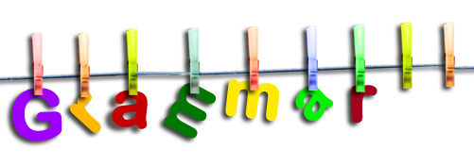



This booklet contains the new grammar and punctuation that your child will be learning about during their time in Year 1. We hope it will be useful in helping you, as a parent, to support your child with their learning.

Capital letter – A letter of the alphabet that usually differs from its corresponding lowercase letter in form and height e.g. A, B, Q, R. Capital letters are used as the initial letter of a proper name, the first word of a sentence etc.
Exclamation mark – A punctuation mark (!) used at the end of an exclamation e.g. What a good friend you are!
Full stop – A punctuation mark (.) used at the end of a sentence e.g. My friend is called Sam.
Letter – There are 26 letters in the English alphabet i.e. a,b, c, d, e, f, g, h, i, j, k, l, m, n, o, p, q, r, s, t, u, v, w, x, y, z.
Plural – A plural noun normally has a suffix –s or –es and means ‘more than one’. e.g. dogs (more than one dog); boxes (more than one box).
Punctuation – Punctuation includes any features of writing other than spelling and general layout e.g. .? ! and also word-spaces and capital letters. One important role of punctuation is to show where a sentence begins and ends.
Question mark – A punctuation mark (?) used at the end of a question e.g. Will you be my friend?
Sentence – A sentence is a group of words which are connected to each other e.g. John went to his friend’s house.
Singular – A word referring to one person or thing.

Word – A single meaningful element of speech or writing, used with others (or sometimes alone) to form a sentence and typically shown with a space on either side when written or printed.

